Name: Kadiyala Naresh

Rg.no.: 192110312

Course: object oriented C++

Code: DSA0163

**1.code:(virtal base class)**

#include<iostream>

using namespace std;

class A{

public:

void display(){

cout<<"I am virtual base class";

}

};

class B :virtual public A{

public:

};

class C: virtual public A {

public:

};

class D:public B, public C

{

public:

};

int main(){

D D1;

D1.display();

}

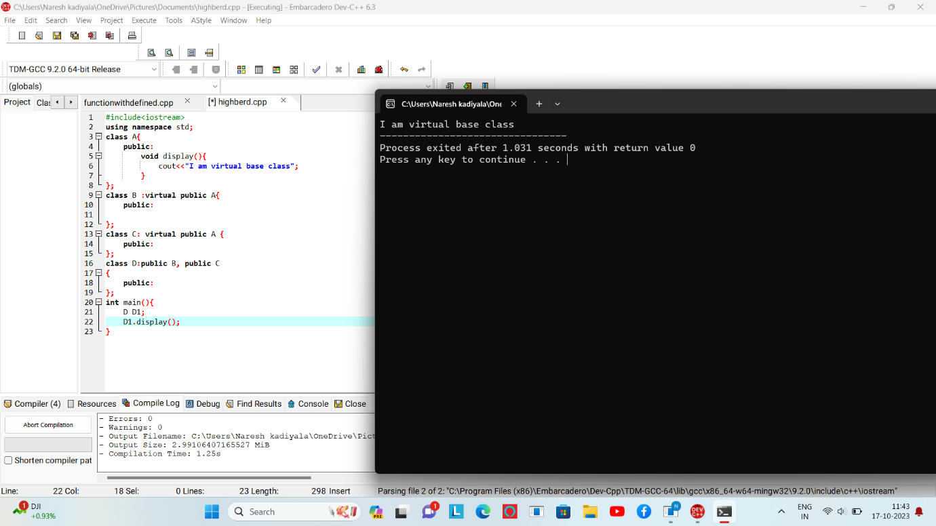

**2.code :- (Function with default arguments)**

#include<iostream>

using namespace std;

class A {

public:

int sum (int a,int b,int c=10,int d=12){

return(a+b+c+d);

}

};

int main(){

A A1;

cout<<A1.sum(10,12,45)<<endl;

cout<<A1.sum(10,20)<<endl;

}

